# KidSights™ Data Consortium

Frequently Asked Questions

What is the KidSights™ Data Consortium?

Established in 2023, KidSights is a subsidiary of Gillette Children’s, a leading U.S.-based specialty children’s hospital, to advance pediatric innovation – and build better futures for children, youth and their families.

KidSights provides access to secure, real-world data, from electronic medical records of specialized (focused on disability) pediatric hospitals.

This data consortium enables global pharmaceutical and medical device companies as well as academic researchers (including Holland Bloorview researchers) to better understand disabilities, developmental differences and rare genetic conditions; to develop personalized therapies and interventions; as well as improve and predict outcomes.

Holland Bloorview Kids Rehabilitation Hospital and Gillette Children’s are the consortium’s first two members.

Why was KidSights created?

While groundbreaking advances have revolutionized adult health care, in large part due to access by researchers to large-scale data sets, innovation in pediatric healthcare, in particular pediatric disability, has often lagged behind. This is a growing concern that demands immediate attention.

KidSights, a North American first, was created by Gillette Children’s to close this innovation gap by bringing a consortium of children’s specialty health-care organizations together.

Their objective is to share secure, de-identified (data from an electronic medical record that does not contain a client’s personal information) clinical data with other member children’s hospitals, industry and researchers. In doing so, KidSights can accelerate knowledge, innovation and new discoveries and advance the health and wellbeing of children and youth with disabilities and developmental differences.

Why is Holland Bloorview becoming a member of the KidSights Data Consortium?

Holland Bloorview joined the KidSights data consortium for many reasons. This membership is aligned with our strategic goals of providing care that’s agile and care that’s transformed by research and education. It will enable us to contribute to and leverage the power of data to understand a person’s unique traits, predict outcomes and inform care, within and beyond our walls.

It also expands our ability to meet the evolving and complex needs of children, youth and families with disabilities and developmental differences and aligns with our journey to becoming a learning health system.

For example, through this membership and access to a global data set of children and youth with disabilities and developmental differences:

* we can help fuel innovations in areas like developing specialized equipment, technology and devices that address the needs of children with disabilities and developmental differences.
* our researchers will have access to the largest datasets in pediatric disability. This means they can better understand and design more effective treatments.
* we can use this data to identify gaps in the health-care system or populations whose needs are not being met to ensure all clients and families are getting the care they need and deserve.

How does the KidSights membership work?

Member health-care organizations such as Holland Bloorview will provide access to their secure, de-identified clinical data/real-world data from their electronic medical records (EMR) or data warehouse. Using privacy-enhanced technology, Kidsights will further de-identify this data. Upon request, researchers from member organizations can access the data to advance their research in pediatric disability and developmental differences. They would send a query for this data to Kidsights, where the de-identified data would be collated for the researcher.

In addition, and with the approval of the health-care organizations, commercial innovators (pharmaceuticals, medical device companies, early-stage startups) can access the data for a fee. They would use these secure, de-identified data sets to develop new products, medical treatments, devices and new drugs to advance the health and wellbeing of clients.

What laws and regulations do KidSights comply with?

KidSights complies with Canadian and U.S. privacy laws, including:

* PHIPA (Personal Health Information Protection Act),
* PIPEDA (Personal Information Protection and Electronic Documents Act), and
* HIPAA (Health Insurance Portability and Accountability Act).

KidSights is prioritizing data privacy through a state-of-the-art, secure data management platform.

 How is my de-identified data in KidSights secured?

Holland Bloorview will store clients’ de-identified data shared with KidSights in a separate secure data warehouse on a separate and secure server. KidSights will then use privacy-enhanced technology to further de-identify and collate the data from participating members.

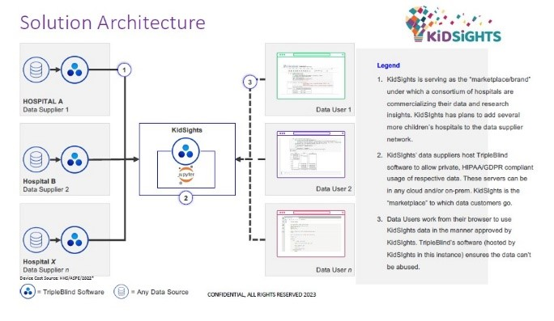

Is Holland Bloorview receiving money from sharing de-identified clinical data through the KidSights membership?

Yes, Holland Bloorview will receive revenue from the KidSights membership generated by end users’ registration fees (pharmaceuticals/medical device companies/early-stage startups).

Holland Bloorview is not paying KidSights to be a part of their membership.

Any revenue we receive will be re-invested into the hospital to support vital services for clients with disabilities and developmental differences and their families.

As with all of our revenue generating programs, the hospital’s business and audit committee, and board of directors will maintain oversight of our financial position.

Where can I find more information about KidSights?

* You can visit our website <http://www.hollandbloorview.ca/KidSights>
* Questions? Please email [info@hollandbloorview.ca](mailto:info@hollandbloorview.ca)  or call the HB Info Line at 416-400-8876.